**BARCODE INFO**

Optimization of Work Flow compared to the Previous System for the Operations and Maintenance Department of Weather.com.ph

Leader:

Miguel Mayor

Members:

Adrian Tobias

Joanna De Guzman

1. **Introduction**

Nowadays, arrangement and management of data has different techniques for different company around the world. These techniques help these companies to increase productivity. With productivity at a high level, surely income will increase too. This study focuses on the improvement on the old algorithm by assigning a new algorithm for the company called Weather.ph. What is Weather.ph? Weather.ph is a company under Aboitiz Equity, and its primary goal is to make all the people in the nation aware about the weather in the different regions of the Philippines. They handle the installation and operation of the weather machines. They have a problem existing in their system which is presentation of data this study makes use of its gathered information and data to focus on exploring that problem.

**1.1 Background of the Problem**

Keeping data consistent is hard. Especially in the Operation and Maintenance Department since they still use excel as of this day to keep their data constant. They record each data from the data logger and put it on excel, then the excel file is passed around the people in the department to ensure that data and information is constant. But the problem is that there is a chance that the data could be overwritten by previous files; new data could be loss for this reason. Work would be delayed and operations will be push back until the data is consistent again.

**1.2 Statement of the Problem**

How do we provide convenience, increase productivity, and improve flow of work to the Operations and Maintenance Department, which still uses the old algorithm?

**1.3 Objectives**

The researchers of the study have decided that the following are the main specific objectives of the study:  
  
- To improve the algorithm to a better and faster way which its productivity is increased by 50%  
- To come up with a proposal of usable methods that can lead into create a algorithm that will solve the problem of Weather.com.ph completely  
- To gather all information and data from such sources like the interviewees, terms and definitions of problem, and related article which contributes in finalizing the best method for the problem.

**1.4 Significance**

The result of this analysis on how to present data and how to collect it will result in a method which will solve the problem that the Weather.ph is now facing. This method when applied to the program that is going to be built in the later subjects, would significantly improve the ease of handling data and information within the company. Specifically, the system will be greatly beneficial to the operations department of the company in handling the equipment used for the company and bring ease to the input and output of data and information. The system will not only bring ease to the collection and manipulation of data, but also increase the reliability against the loss or errors that could occur to the information they require. The system will also greatly benefit the maintenance personnel due to the fact that they could easily determine the exact quantity of the equipment, the quality, and the availability.

**II. Scope and Limitations**

The department that will be using this system are the operations & the maintenance department. The study will not cover other departments such as financial department, Human resources, etc. This system is limited to the operations & maintenance departments. This study is also limited to the improvement of the old system by proposing a new algorithm, which provides convenience and increase in productivity in the Operations and Maintenance department of the company; it does not focus in other problems in the company.

## IV. Theoretical Background

### Pomodoro Technique

Pomodoro Technique is a method which maximizes productivity with the association of time limit and time allotment. Each Pomodoro(Timer) consists of 25 minutes and there are certain objectives to follow for this technique.

#### 

#### **Objectives**

1. Find out how much effort and activity requires you by monitoring how many Pomodoros you need in order to accomplish a specific task.

2. Learn to protect your Pomodoro from internal and external interruptions.

3. Make accurate estimations of how many Pomodoros you need for a certain activity.

4. Use your pomodoro time not just to work on your task but spend a few minutes for recap and the last ones for review.

5. Set a time table according to your to dos, to your time, or to the season. This is good for organizing work and creating more time.

6. Once you have a completed the objectives, find your own personal objective such as being more efficient or improving work quality.

* Do not skip objectives, finish an objective before moving on to the next one.
* Simple but effective way to improve work. Basic requirement is to have a timer.

#### **Pomodoro Algorithm**

Based from the process of the Pomodoro Technique, the researchers of this project have formulated a pseudo-code or the Pomodoro Algorithm.

##### **Pseudo-code**

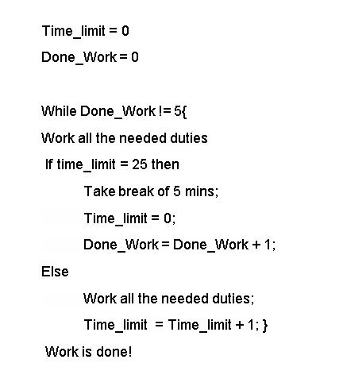

### Jerry Seinfeld Algorithm

Based on the celebrity Jerry Seinfeld, which was known during his prominent TV “Seinfeld”, created a method to maximize his work out every day in his career as a comedian. His method portrays the needed objectives and the time to execute and achieve the goals stated.

#### **Objectives**

There are objectives to perform this method and here are the objectives:

1. Create task for every day of a Calendar

2. Cross out each day after all work is done which has been stated

3. Don’t break the chain of the crossed out days and continue this method

##### **Pseudo-code**

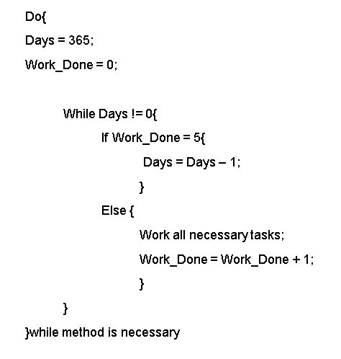

**Sources:**

<http://pomodorotechnique.com/>

<http://lifehacker.com/281626/jerry-seinfelds-productivity-secret>

## V. Proposed Solution to the Problem

The problem of the company, as stated previously in this paper, was that the productivity of the Operations and Maintenance Department was slow because their method of being notified and alerted of the broken weather machines were delayed by some factors. Their process was this list of steps:

1. The Maintenance Team were to access Philstation to check if there are any broken weather machines  
2. Technicians will list down the weather stations which are broken  
3. They will call the site manager to try to fix the weather station  
4. If maintenance through phone doesn’t work, site visit is going to be mandatory  
5. After site visit, service report is created and filed into the laptop of the Manager

Since this process is primitive and stuck on manual mode, the researchers came up with a new algorithm which will solve the slow response time and lack of reliability, and replace with a new system which provides more productivity, faster response time, and more reliable ways to determine what tasks are to be accomplished.

The first implementation in the system is that the data quality team should be the ones to notify whether there is a broken weather machine or not, since they handle the status of the weather station. After that, they will send a service request to the technicians so that the whole transaction between data quality team and technicians are recorded. After receiving the service request, they will contact the site manager to try to fix the weather station through the phone since it may be the first solution to fixing the problem. The conversation is recorded and the site manager will try to fix the weather station through the instructions of the technicians. If the weather station isn’t fixed, they will schedule a site visit for maintenance. In the course of the maintenance, they will file a service report and it is automatically saved through the database. The Data Quality team will double check if the weather station is working and they will send a confirmation to the technicians. Technicians will send the service report to the technician head and the head will review the finished report. That marks the end of the new algorithm.

This new algorithm provides convenience and reliability in the department because there are sections and steps in the algorithm which solves the problem occurring in the department. With the process of the service reports and the process of the confirmation with many actors makes the system reliable. One major factor of the new algorithm that improves the systems is the time variable. The old system of the department wasn’t time-conscious, therefore creating a system that is too relaxed. The new algorithm in the system makes sure that work is done within a certain limit, but in the end, rewards the employee for accomplishing work within the allotted time limit. This is the implementation of the researchers’ Pomodoro Algorithm. Another variable that plays an important role in the new algorithm is the consistency variable. This algorithm follows a certain order so that work is done in an orderly manner and everything from the service request until the finishing process is recorded for future reference uses. This is the implementation of the Seinfeld Algorithm

**VI. Results and Discussions, includes theoretical proof, verification, or evidence**

**VII. Conclusions and Recommendations**